Last Update: May 1, 2023

Enterprise Route Management

*Environment Setup and Configuration Guide*

**Table of Contents**

**Section Title Page**

1.0 About This Document 2

1.1 Purpose 2

1.2 System Overview 2

1.3 Environment Assumptions 2

2.0 Requirements 3

2.1 Software 3

2.1.1 10.9.1 Patch 3

3.0 Enterprise Server 4

3.1 Enterprise Install 4

3.2 Routing Services 4

3.2.1 Install on 10.9.1 4

3.2.2 Configure Routing Services 5

3.2.3 Routing Service in Portal 7

4.0 Middleware Server 8

4.1 Node.js 8

4.2 IIS 8

5.0 Web Server 9

5.1 IIS 9

6.0 General System 10

6.1 Certificates 10

6.1.1 Domain-signed 10

6.2 URLs 10

Appendix A Environment Checklists 11

Before Setup 11

Environment Preparation 12

Appendix B Document History 13

1. About This Document
   1. Purpose

This Environment Setup Guide serves to document steps for software installation and system configuration that is required before deploying the Enterprise Route Management system.

Steps to deploy the custom ERM application components are covered in a separate document *ERM Application Deployment Guide* available in the [ERM GitHub Document repository](https://github.com/EsriPS/enterprise-route-management).

See *Appendix A Environment Checklist* for a list of basic tasks to complete.

* 1. System Overview

There ERM environment is made up of 3 components:

* An ArcGIS Enterprise deployment with Portal, Server and relational Data Store. (Referred to as “Enterprise” throughout this doc).
* A dedicated Windows server that hosts the ERM API service. (“Middleware”)
* A web server that hosts the ERM web application. (“Web Server”)

It is recommended for a Production environment that these 3 components are placed on three separate machines, either cloud based or physical. The Enterprise deployment itself could be spread across multiple machines. For lower environments, such as development or test, these could be combined to use fewer machines.

These instructions assume 3 separate servers and standing up environment from scratch. Existing web server or ArcGIS Enterprise deployment can be used if they meet requirements.

* 1. Environment Assumptions
* The Middleware API will be exposed as a site through IIS. This site will need to be public facing for the application to access.
  + “Public” in this sense can be an intranet
* Any needed certificates are installed so different machines in the ERM system can talk to each other.
  + If using the sample BSI service with domain certificates, will need a .pem version on the server. See section 6.1 for more info.

1. Requirements
   1. Software

These applications are required for ERM to run.

* ArcGIS Enterprise version 10.9.1 or later.
  + ArcGIS Portal, Server, relational Data Store, and WebAdaptors (for Portal and Server).
  + Along with any applicable patches
* ArcGIS Pro 2.8 or later
  + Does not need to be installed on any specific ERM server, only needs to be able to access the Portal to publish services.
* Street Map Premium 2019 or later
  + Along with the SMP license, to deploy will require a Network Analyst extension license.
  + This would be deployed on the Enterprise server. Due to size of files, it is recommended to have a minimum 250GB hard drive for the SMP files. Or place on separate partition.
* [Node.js](https://nodejs.org/en/download/)
  + ERM version 4.0, any 18.x is acceptable.
  + ERM version 3.5.x , any 16.x is acceptable.
* IIS enabled on Middleware and Web Server
  + Including these IIS Modules on both
    - [URL Rewrite](https://www.iis.net/downloads/microsoft/url-rewrite)
    - [ARR](https://www.iis.net/downloads/microsoft/application-request-routing)
* Browser: Chrome, Firefox, or Edge
  + Internet Explorer is not supported
    1. 10.9.1 Patch

If using ArcGIS Server 10.9.1, there is a patch for the Vehicle Routing Problem that will also need to be installed.

Can be downloaded from [here](https://support.esri.com/en/download/7992).

1. Enterprise Server

These steps will be performed on the machine hosting ArcGIS Enterprise.

* 1. Enterprise Install

ERM uses a base configuration ArcGIS Enterprise with Portal, and Server with a relational Data Store. There is nothing custom required for ERM, so the [core installation instructions](https://enterprise.arcgis.com/en/documentation/install/) can be used.

|  |  |
| --- | --- |
|  | * Enterprise can be on Windows or Linux. * All documentation for ERM assumes Windows. * If using Linux should only need to adjust paths and commands for file locations given in examples. |

* 1. Routing Services

The ERM uses the Vehicle Routing Problem (VRP) within Network Analyst geoprocessing service to solve routes. The services needed can be deployed with StreetMap Premium (SMP) for ArcGIS.

Information on downloading SMP can be found [here](https://doc.arcgis.com/en/streetmap-premium/get-started/download-guide.htm).

Basic publishing instructions are included in this doc. More information on publishing routing services can be found [here](https://enterprise.arcgis.com/en/server/latest/administer/windows/publishing-routing-services.htm).

* + 1. Install on 10.9.1

|  |  |
| --- | --- |
|  | * The built-in scripts changed between 10.8 and 10.9, from a python script to a bat file |

1. On the Enterprise server, create a folder to hold the SMP data.
   1. i.e., C:\arcgis\ERM \SMP\North_America_2021
2. Create a folder to hold services
   1. i.e., C:\arecgis\ERM \RoutingServices\ServiceDefinitions
3. Download the SMP files and extract each zip from StreetMap Premium into your folder
   1. Zips can be different based on SMP version being used. After being extracted you should have a North_America.gdb at the end.
4. Use the publish routing services bat file included with Server to publish SMP.
   1. Run the code sample below from an admin command prompt. Update paths and information where applicable.

"C:\Program Files\ArcGIS\Server\tools\PublishRoutingServices\publishroutingservices.bat" -s <server name> -P <server name> -u <admin user> -p <password> -o C:\arcgis\RoutingServices\ServiceDefinitions -n C:\arcgis\SMP\North_America_2019\NorthAmerica.gdb\Routing\Routing_ND

* 1. The publishing bat file path might be different depending on where server was installed.
  2. For server name, use the fully qualified domain name of the Enterprise machine.
  3. For admin user and password, use an ArcGIS Server admin account.
  4. The NorthAmerica.gdb\Routing\Routing_ND path may be different, depending on where you extracted your data.

1. Open Server Manager and verify 4 published services in Routing folder.
   1. NetworkAnalysis (GP Service)
   2. NetworkAnalysis (Map Service)
   3. NetworkAnalysisSync (GP Service)
   4. NetworkAnalysisUtilities (GP Service)
      1. Configure Routing Services
2. Open Server Manager and verify 4 published services in Routing folder.
3. Under Routing folder, open the NetworkAnalysis geoprocessing service.
   1. Note there is a map service with the same name
4. On the Parameters page, verify the Maximum Number of Records returned by Server to at least 10000.

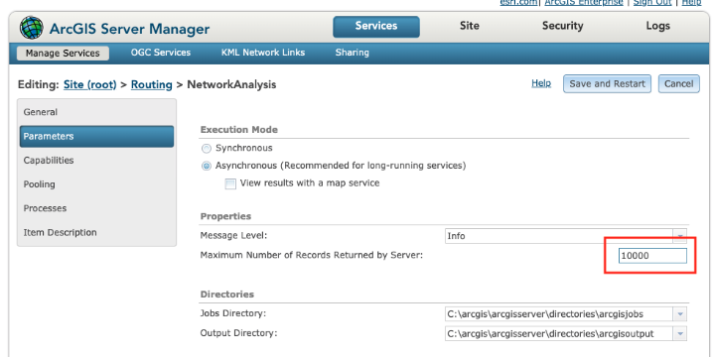

1. On the Pooling page, verify the Max time a client can use a service to at least 1800.

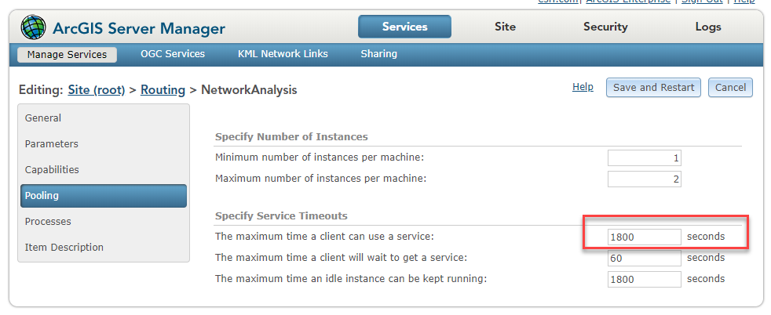

1. If changes were made, click Save and Restart button.

**Optional – Set Routing Messages**

The level of detail in messages that the routing service returns can be set on the Network Analysis service. This setting will control how much detail is shown in dialog when Solve is run in the Route Planner application.

1. Open Server Manager and open the Routing\NetworkAnalysis geoprocessing service.
2. Open Parameters tab.
3. Choose the Message Level you want.
4. Save and restart the service if change made.

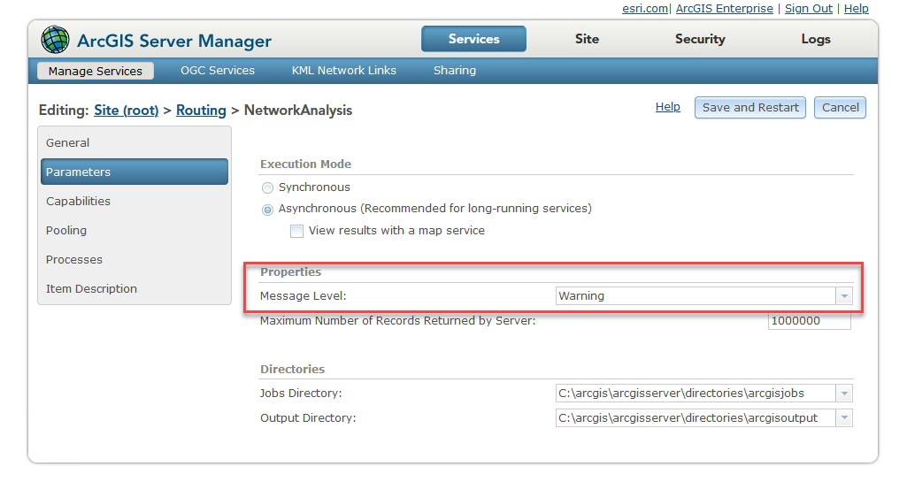

* + 1. Routing Service in Portal

Configure the routing service in Portal

1. Log into Portal as admin
2. Go to Organization > Settings > Utility Services
3. Under Directions and Routing section, set Route option and enter the URL for your Network Analysis service
   1. If Portal and Server federated, the URL should be set automatically
4. Note the Travel Modes that are created by default. More details on how to use these are included in the *ERM Application Deployment Guide.*

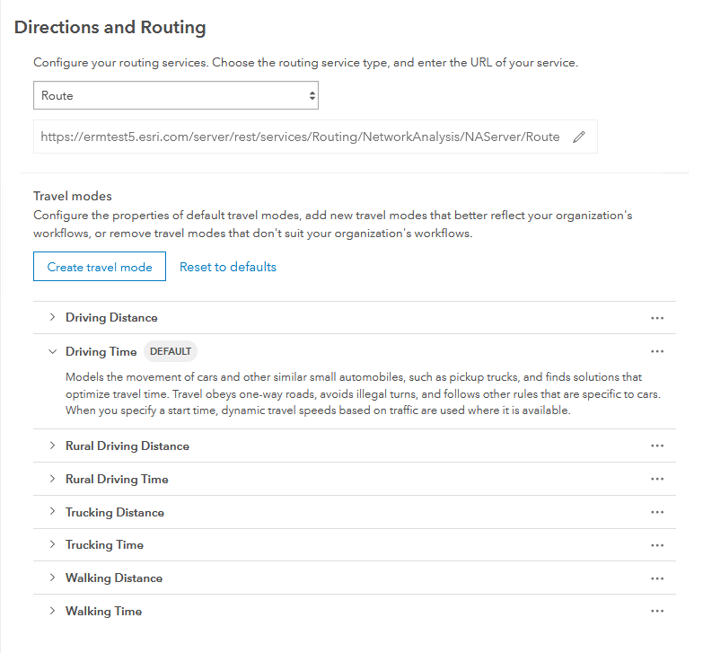

1. Middleware Server

These steps will be performed on the machine hosting the ERM middleware API.

Middleware server will use Windows Server 2019 or later.

* 1. Node.js

1. Install correct 64-bit version of LTS from <https://nodejs.org/en/download/>
   1. See requirements section for version info based on ERM version
   2. Use all defaults in installer. Do not need to include extra tools option.

|  |  |
| --- | --- |
|  | * As of ERM version 4.0, do not need NODE_ENV environment variable |

* 1. IIS

When the middleware API is deployed, it will need a site in IIS. These are precursor steps.

1. Enable IIS on machine through Server Manager
2. Open IIS and browse to default web site
3. Choose Bindings
4. Select HTTPS and click Edit
5. Set your SSL certificate
6. Install both the [URL Rewrite](https://www.iis.net/downloads/microsoft/url-rewrite) and [ARR](https://www.iis.net/downloads/microsoft/application-request-routing) modules
7. Web Server

The Route Planner application will be hosted on a Web Server.

It is assumed the Web Server will be a separate machine from Enterprise and Middleware, possibly leveraging existing Web Server.

* 1. IIS

These are precursor steps before deploying Route Planner on the Web Server.

1. Enable ISS on machine through Server Manager.
2. Open IIS and browse to default web site
3. Choose Bindings
4. Select HTTPS and click Edit
5. Set your SSL certificate
6. Install the IIS module [URL Rewrite](https://www.iis.net/downloads/microsoft/url-rewrite).
7. General System
   1. Certificates

Any certificates required for the servers to talk across the network will need to be installed and files available for use during Enterprise install.

* + 1. Domain-signed

By default, Node.js does not accept domain-signed certificates. To run this application against an ArcGIS Enterprise deployment with domain-signed certs, follow these steps:

1. Download the domain root certificate and transform it to a .pem file if needed. Save the certificate file somewhere that the node app and geoprocessing services can access.
   1. Place in a local folder such as C:\_certs
2. Add an environment variable NODE_EXTRA_CA_CERTS set to the path of this certificate

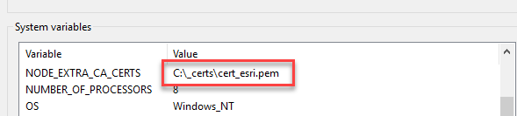

1. Repeat for both Middleware and Enterprise machines.
   1. URLs

May need to work with customer IT staff to configure a URL that users will use to hit the web planner app if not using the machines qualified domain name.

https://<your URL or machine name>/routeplanner

https://<your URL or machine name>/ermapi

1. Environment Checklists

Before Setup

Here is a list of tasks to be done and files to be downloaded before any software is installed. Normally a customer IT staff would be responsible for these actions or downloading files, especially if system is locked down without internet access.

|  |  |
| --- | --- |
| **Task** | **Complete** |
| Servers requisitioned and ERM roles defined for each |  |
| Certificates installed on all servers -If using domain certs, convert to .pem file and make available for use by ERM |  |
| SMP files downloaded -Along with license file -Will need 7zip application if files are .7z |  |
| Node.js installer downloaded |  |
| IIS enabled on Middleware server Along with URL Rewrite and ARR modules |  |
| ArcGIS Pro available -Or installer and license available |  |
| IIS URL Rewrite and ARR Modules installers downloaded |  |

Environment Preparation

Here is a high-level list of tasks to complete to prepare the environment for deployment of the ERM application.

|  |  |
| --- | --- |
| **Task** | **Complete** |
| ***Enterprise*** | |
| ArcGIS Enterprise installed Includes Portal, Server, Data Store, WebAdaptors + any patches |  |
| Routing services from StreetMap Premium published |  |
| Portal configured to use routing services |  |
| ***Middleware*** | |
| Node.js installed on Middleware server |  |
| IIS enabled on Middleware server Along with URL Rewrite and ARR modules |  |
| ***Web Server*** | |
| IIS enabled on web server to host Route Planner Along with URL Rewrite and ARR modules |  |
| ***Other*** | |
| Any certificates needed for communication between machines are installed |  |
| Configure URLs if not using machine names |  |
| Pro is available |  |

1. Document History

| Date | Description | Editor |
| --- | --- | --- |
| 5/22/2020 | Initial Draft v0.1 | Mike Nelson |
| 3/5/2020 | 10.7.1 initial version | Mike Nelson |
| 6/12/2020 | Updates for 10.8, various edits | Mike Nelson |
| 7/2/2020 | apply feedback from Dev deployment | Mike Nelson |
| 9/14/2020 | Updated steps for Route Service o updated default value | Mike Nelson |
| 11/17/2020 | Added detail about routing message level | Mike Nelson |
| 12/8/2020 | Detail in URL rewrite about double http | Mike Nelson |
| 4/30/2021 | Update for Enterprise version | Mike Nelson |
| 5/12/2021 | Updates for Enterprise and Node versions | Mike Nelson |
| 5/24/2021 | Minor updates and info with Travel Modes | Mike Nelson |
| 11/10/2021 | Updates to Prerequisites and version info | Mike Nelson |
| 12/22/2021 | Fix for ERM version vs Node version | Mike Nelson |
| 8/18/2022 | General updates and clarifications for updated software with version 3.5 | Mike Nelson |
|  | General updates for version changes with ERM 4.0. Removed all 10.8.1 mentions | Mike Nelson |